Carmen Mendoza

CSD 340

Module 3.2 Assignment

For the verification I uploaded my file from computer:

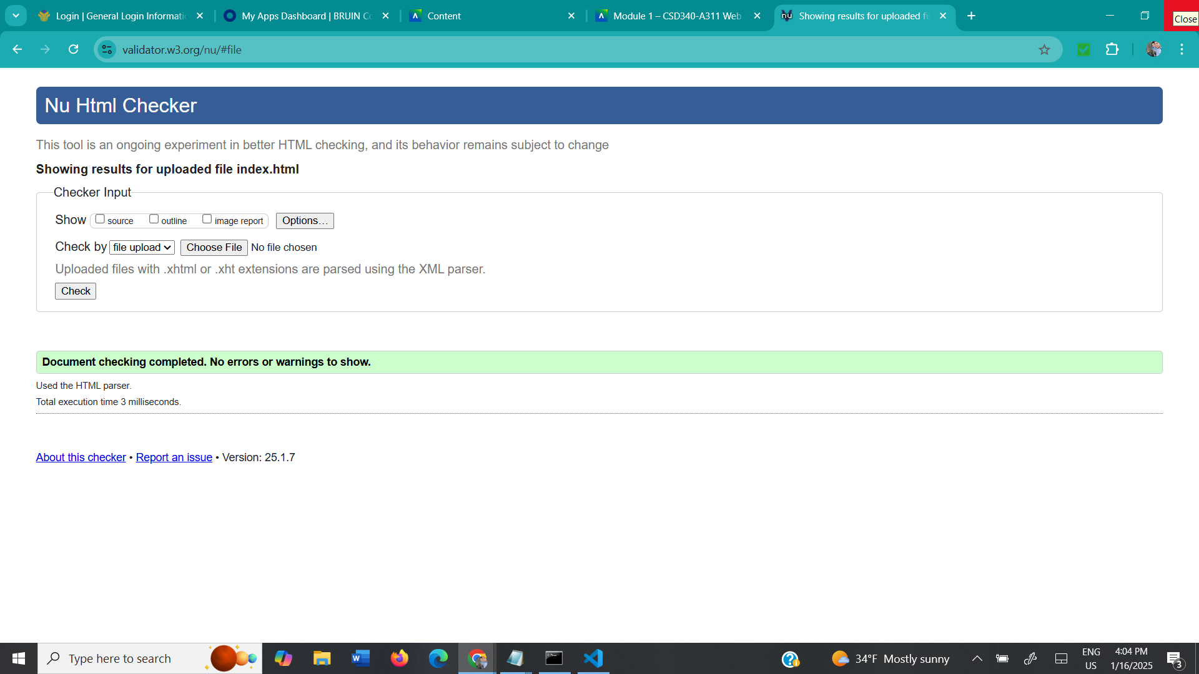

I also used the same method of uploading the file for the CSS. File:

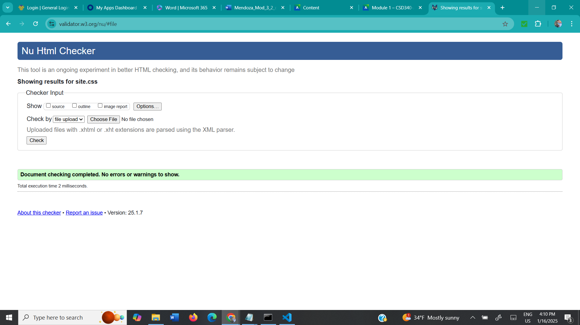

Screenshot of my landing page: 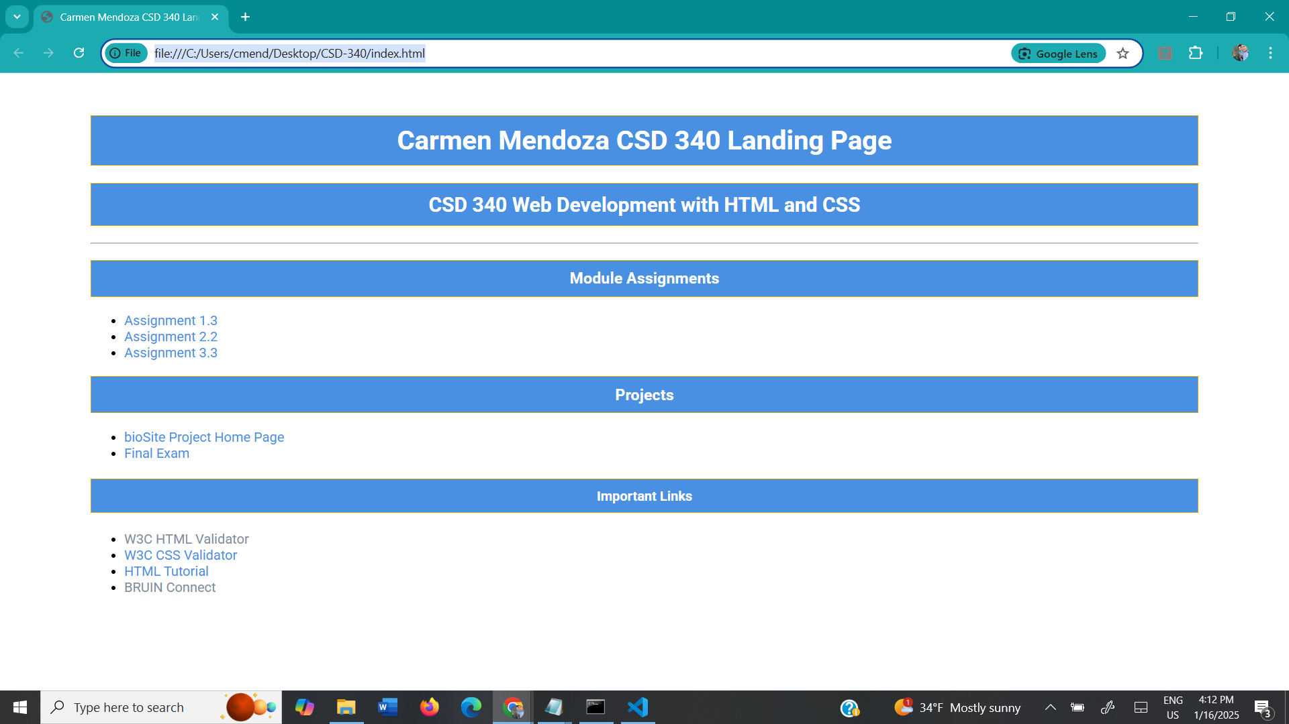

Link to browser: <file:///C:/Users/cmend/Desktop/CSD-340/module-3/index.html>

Link to GitHub: https://github.com/cmendoza-cloud/CSD340/tree/main/Module-3